# Introductions

Public Transportation creates alternatives for people so they can move from one place to another. Citizens move from their houses to work places and other services like hospitals and stores on a daily base. Public transportation provides them with a comfortable and efficient option to transport them to the places they want to visit. This study is going to demonstrate how the public transportation can be thrive in a place where the city has high population with less defined routes of public transportation. There is no proper system implemented in the public transportation so that the citizens are facing problem on daily basis.

Transportation in Nepal especially in Kathmandu is becoming more and more disturbing and dangerous. The vehicles in the road always seems to be crowded and the volume is higher in the peak hour. There is a high traffic jam and the vehicles need a long period of time to cross certain distance. As the number of vehicles plying on the roads of Kathmandu city has reached 800,000, and it is indispensable to take technical support to manage the traffic in Kathmandu. The problem of traffic is directly linked with a country’s economic progress because the number vehicle rises with economic development. There are basically two alternatives to resolve the traffic congestion to widen the road and manage the traffic.

Small vehicles are growing day by day in the capital city. Every year around 20 percent of vehicles are growing in the Kathmandu city. If the trend continues, it will be difficult to manage traffic no matter how wide the road is expanded. Thus, big vehicles are the alternative to small vehicles. The traffic management will take a giant leap forward if big vehicles could be brought to replace smaller vehicles. The rise in big vehicles will make the number of vehicles sparse. Nepal government has been operating 56-seater Sajha Yatayat buses. The government should encourage operation of big buses in Kathmandu and small vehicles should be allowed only in inner roads. Big vehicles consume less fuel that will be helpful in keeping the environment clean. Bigger cities in the world are operating big buses. Today the roads have become a torture place for Nepali people. People are not being able to reach their destinations on time due to traffic jams and the roads are becoming chaotic and accidents have been rising.

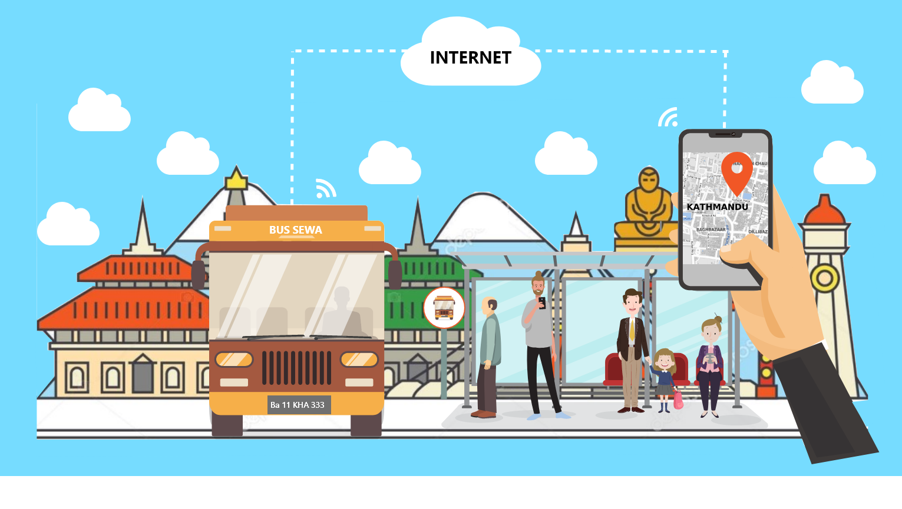

Figure : Brief Illustration

It’s high time that Nepal government learnt from the experiences of other cities around the world to promote public transportation. The public transport has the capacity to improve the people’s living standards, resolve the challenges of growing vehicles and control the road accidents. Today Nepali people need a clean, secured, comfortable and cheap public transport that can attract and serve people from all classes. When the service of public transport reaches the level of private transport, then people from all class will be attracted to public transport. In developed country, people from all class use public transport. The public transportation service should be operated round the clock in order to make it more credible. Easy means of transportation will be helpful in increasing economic situation. People can easily commute to work and won’t have to worry about getting back home after work.

# Aims

To be able to research the condition of public transportation and develop a mobile base application to provide a possible solution to the commuters.

# Objectives

## Personal Objectives

* To develop time management and communication skills
* To produce quality works
* To read various research papers and books
* To learn about the oracle administration in Linux

## Academic Objectives

* To study similar papers and case study
* To complete the dissertation and product before the deadline
* To successfully obtain bachelor’s degree

## Technical Objectives

* To learn how the system could be digitalized.
* To learn about the security measures regarding the system and commuters
* To learn about various concept of database
* To compare the status of public transportation
* To build an android application
* To test and implement the end product

# Justification

Public transportation is the one the most importation infrastructure that are need by the citizen of cities. People have to wait the buses for long period of time, they can’t know the arrival time of the buses. Due to heavy traffic congestion and road construction public vehicle often late at the bus stop. The commuters are not able to get a comfortable sit while commuting. To get comfortable sit, it would be a dream come true for a commuter. The frequent and irritate problem faced by the passengers are the rudeness of driver or a conductor, they often break the rules and tries to overload with higher the capacity of the bus. The poor management of public transportation system leads in increases number in private vehicles which makes the city full of pollution and traffic congestion. With an increase in population on cities, increases the number of passengers on a rush hour. As a result, the commuters are late to works, students are late on their classes.

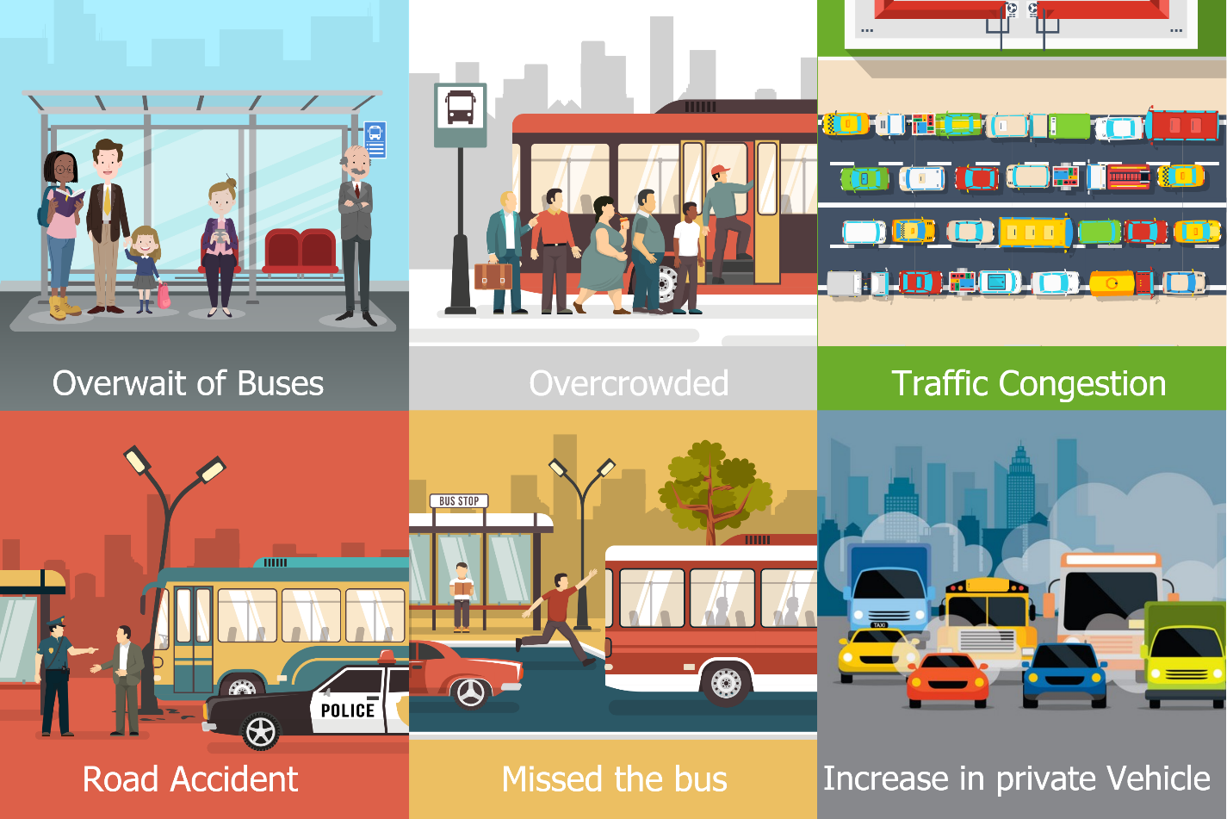

Figure : Problem Statement

# Research Questions

* What is the factor that the public transportation of Nepal is not like a UK public transportation?
* Why public transportation of Nepal is not digitalized?
* How the digitalized system of public transportation helps in controlling the traffic congestion?
* What is the reason behind the public transportation that it couldn’t been developed yet?

# Mini Literature Review

The similar project has been conducted by many researchers on context to their locality and there are lots of successful innovation and proper public transportation system to learn, observer and to implement those system and them to adapt their workflow. Likewise, TFL is the most advance public transportation system considering to present scenarios. The TFL system are able to handle the millions of passengers on single day with out any rush and inconsistence. The passenger is able to travel with safe and with out any fear to be late on their work or college. They are able of manage the more than a million passengers with their proper transportation system. If there is any occurrence of problem, they pre informs to their passenger through a devices and news so that the passenger is able to maintain their schedule on time.

The air traffic control system uses the GPS technology in order to communicate and provide the real time location of airplanes. The minimum glitch on their system could cost a life of travelling passengers. Their work should be very precise to provide a best safe service to the passengers. The programs and hardware are embedded across million lines in size which guarantees the safety of the passengers. Its shows the complexity of the GPS technology and the capacity of using it.

## Methodology

The waterfall methodology is a sequential management approach, where the requirement is gathered at the initials of the project, and follows the steps on a sequence order to accommodate those requirements. Though the research is only conducted by the single person, the waterfall methodology would be suitable of those type of research. On the first phase of the methodology, requirement can be gathered through various method like survey, questionnaire and interviews etc. After the requirement are gather properly, the design is made considering the requirement process. The logical subphase shows the possible problems solutions with brainstorming and theorized. Implementation phase starts after the completion of design phase, here the product is made with the actual code. On another phase, the testing and verification of the product is done. At the end of the research or a product, the maintenance is done if the error is found on a pervious phase and it is deployed to the end users.

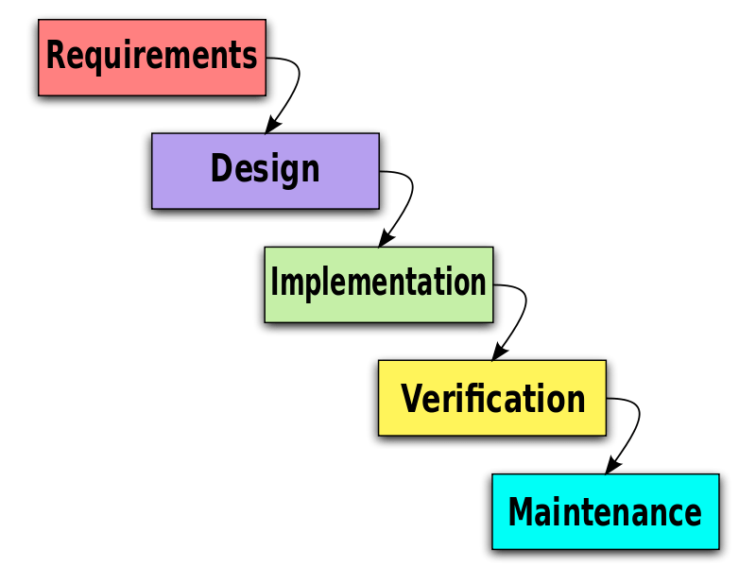

Figure : Waterfall Methodology

## Tools and Technologies

On this project, different tools are need in completion of the project. The tools which would be use on this project are listed below with their short description on purpose of using it.

* Adobe photoshop cc 2019 – this application is used to modify and design the picture/diagram for better illustration on writing documents and while developing an application.
* Adobe xd – this tool will be also use to design the picture/diagram.
* Android studio - this software will be used to develop an android application.
* Pichon – this application will be used for finding icons and using them on an android application.
* Oracle database 11g – it is a database management system and will be used as a database.
* Oracle vm virtualbox - this software will be used to install a Linux operating system i.e. Oracle Linux
* Putty – this application will be used to access to a Linux system
* MS office – this application will be used for making Gantt chart with timeline of the project other simple task.
* Visual code studio – this application will be used while developing an android application.
* Sql tool – This application will be used to excess the oracle database.

# Deliverables

Deliverables is an element of output within the scope of a project. Within a single project, many deliverables can be found. It mentions the deliverables on a certain date. The figure below illustrates the deliverables of this research.

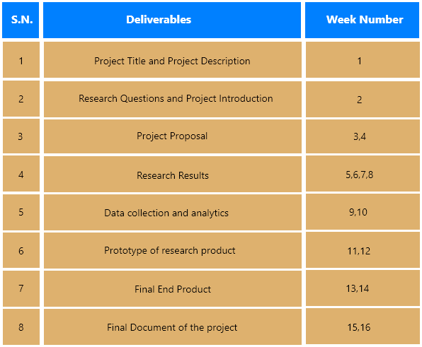

Figure 4: Deliverables

# Project Plan

<https://www.teamgantt.com/guide-to-project-management/how-to-plan-a-project>

Project plan is a rule book that shows how to manage the project through its completion. In other words, the process of establishing the objectives and steps to attain them with a proper scope is project plan. There are the different steps that should be followed to achieve goals of the project. It provides detail information and user story to manage the project

## Time Schedule

The listing of milestones, activities and deliverables with a project is time schedule. It basically includes the start date and end date of the project which helps to estimate the completion time of the overall project. It distributes the heavy task into a small chuck which helps to solve the problem the upcoming dependencies problems.

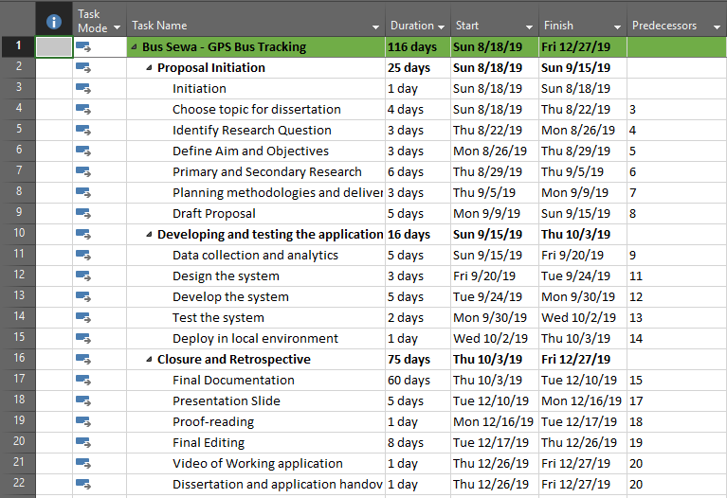

Figure 5: Time Schedule

## Gantt Chart

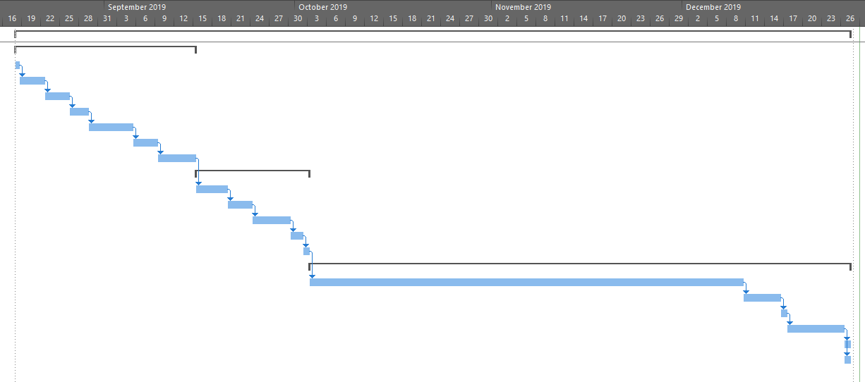

Figure 6: Gantt chart

# Risk Planning

<https://mymanagementguide.com/project-risk-planning-process-the-key-steps-of-the-process/>

The project always generates a challenge, to overcome those challenges in an efficient way to respond is risk planning. The risk plan helps to solve those challenges by planning for the negative impact of the risks and developing solutions that reduces the likelihood of risk occurrence. The study of every potential risk of the project helps achieving the target. It helps in managing, identifying and prioritizing the risk.

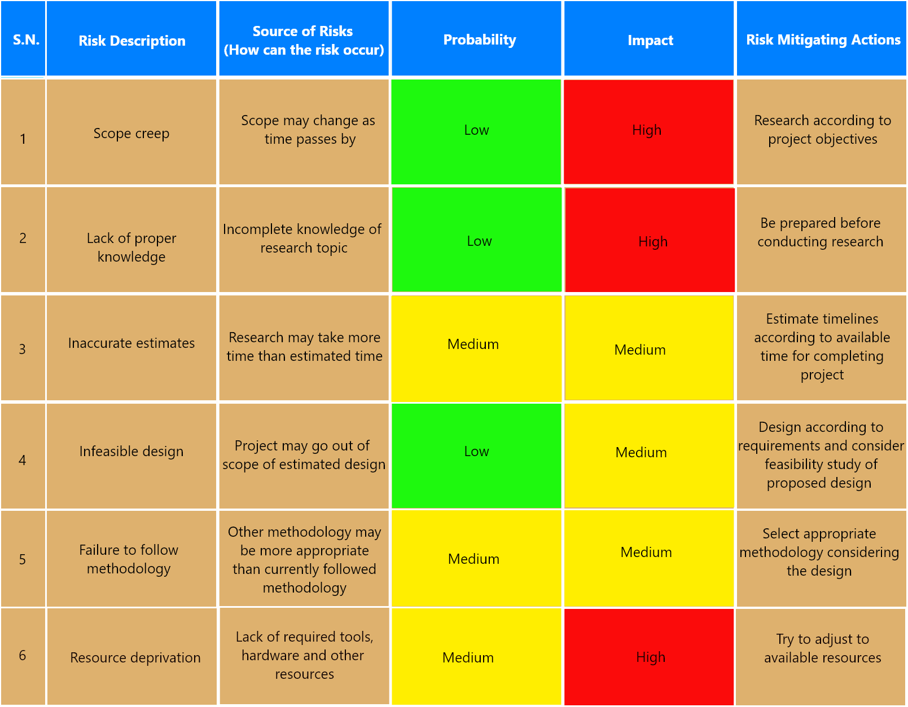

Figure : Risk Plan